**COMP1003 Maths Worksheet**

1. Compute sin(.1) using the Taylor expansion from the lectures up to 3 terms.

From the lecture

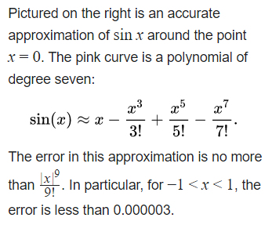

sin( .1 ) = .1 - .001/6 + .00001/120 +- .. =

1. Assume you have 2 data points (x,y)= (0,1) and (2, 3). Computer linearly interpolated y-values at x=0.1, 0.25, and 0.5

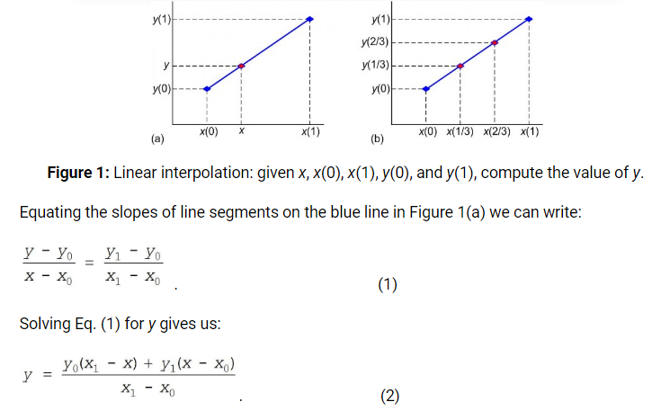

(x0,y0) = (0,1) ; (x1, y1) = (2,3)

y = [1(2-x) + 3(x-0)] / (2-0) = (2-x+3x)/2 = (2x+2)/2 = x + 1

y(x=0.1) = 1.1 ; y(.25) = 1.25 ; …

1. Estimate the slope of x2 at x=1 using a few secants that get closer to the tangent.

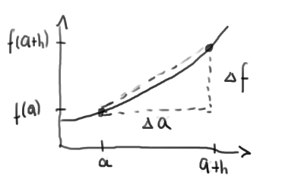 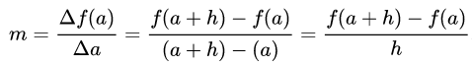

h = .5

Delta f(1) / Delta a ~ (f(1+.5) – f(1))/ (1+.5 – 1) = (1.5*1.5 – 1)/.5 =1.25/.5 = 2.5

h = .1

Delta f(1) / Delta a ~ (f(1+.1) – f(1))/(1+.1 – 1) = (1.1*1.1 – 1)/.1 = .21 /.1 = 2.1

h = .01

Delta f(1) / Delta a ~ (f(1+.01) – f(1))/ (1+.01 – 1) = .0201/.01 = 2.01

The series 2.5, 2.1, 2.01 .. gets closer and closer to 2

The exact slope of f(x)=x2 in x=1 is the value of the derivative f’(x) = 2x, which equals 2 for x=1.

1. Compute an approximate integral of x2 over the range -1 to 1 using 8 slices for the Riemann sum.

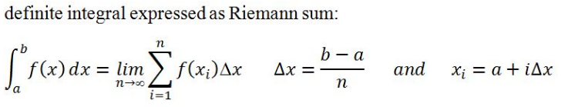

x2 is mirror symmetric at the y-axis. It suffices to compute only 4 positive slices and multiply their sum by 2 for the negative part of the integral.

4 slices from 0 to 1 imply a stepsize delta x = .25 for the slices.

If f(x) = x2the integral from -1 to 1 is therefore roughly:

I ~ 2*.25*( f(.25) + f(.5) + f(.75) + f(1)) = .5*(0.0625 + .25 + .5625 + 1) = .9375

The indefinite integral of x2is x3/3.

According to the fundamental theorem of calculus the exact integral is therefore

(13 – (-1)3)/3 = 2/3 = .666

The approximate value .9375 is not particularly close. We should use a finer stepsize/more slices.

1. Compute an approximate zero crossing of the function x3 + 1 using Newton’s method.

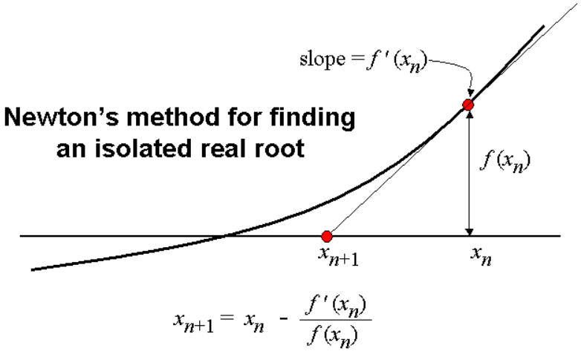

f(x) = x3 + 1 -> derivative is f’(x) = 3 x2

We know that the root is at x=-1; but we want to get an approximate value using Newton’s method. We can start with x=0

x0 = 0 -> x1 = 0 – 0/1 = 0 = x0

That does not work; because the derivative f’ is 0 at x=0.

Lets try x0 = -0.5 -> x1 = -0.5 – 3*0.52 / (0.53 + 1) = -.5-.6666 = -1.1666

We have got closer to the root at -1

More iterations should bring us closer..

1. Compute an approximation of the location of the minimum of the function f(x) = 1/4 x4 + x using Newton’s method

The minimum is where the derivative of f(x) has a zero crossing.

The derivative of f is f’(x) = x3 + 1

This is the same function as in task 5. We have computed and approximation of the zero crossing there.

1. Do some reading about the Fast Fourier Transform. What does it do? What are some applications in Computing?

Left as a reading exercise.